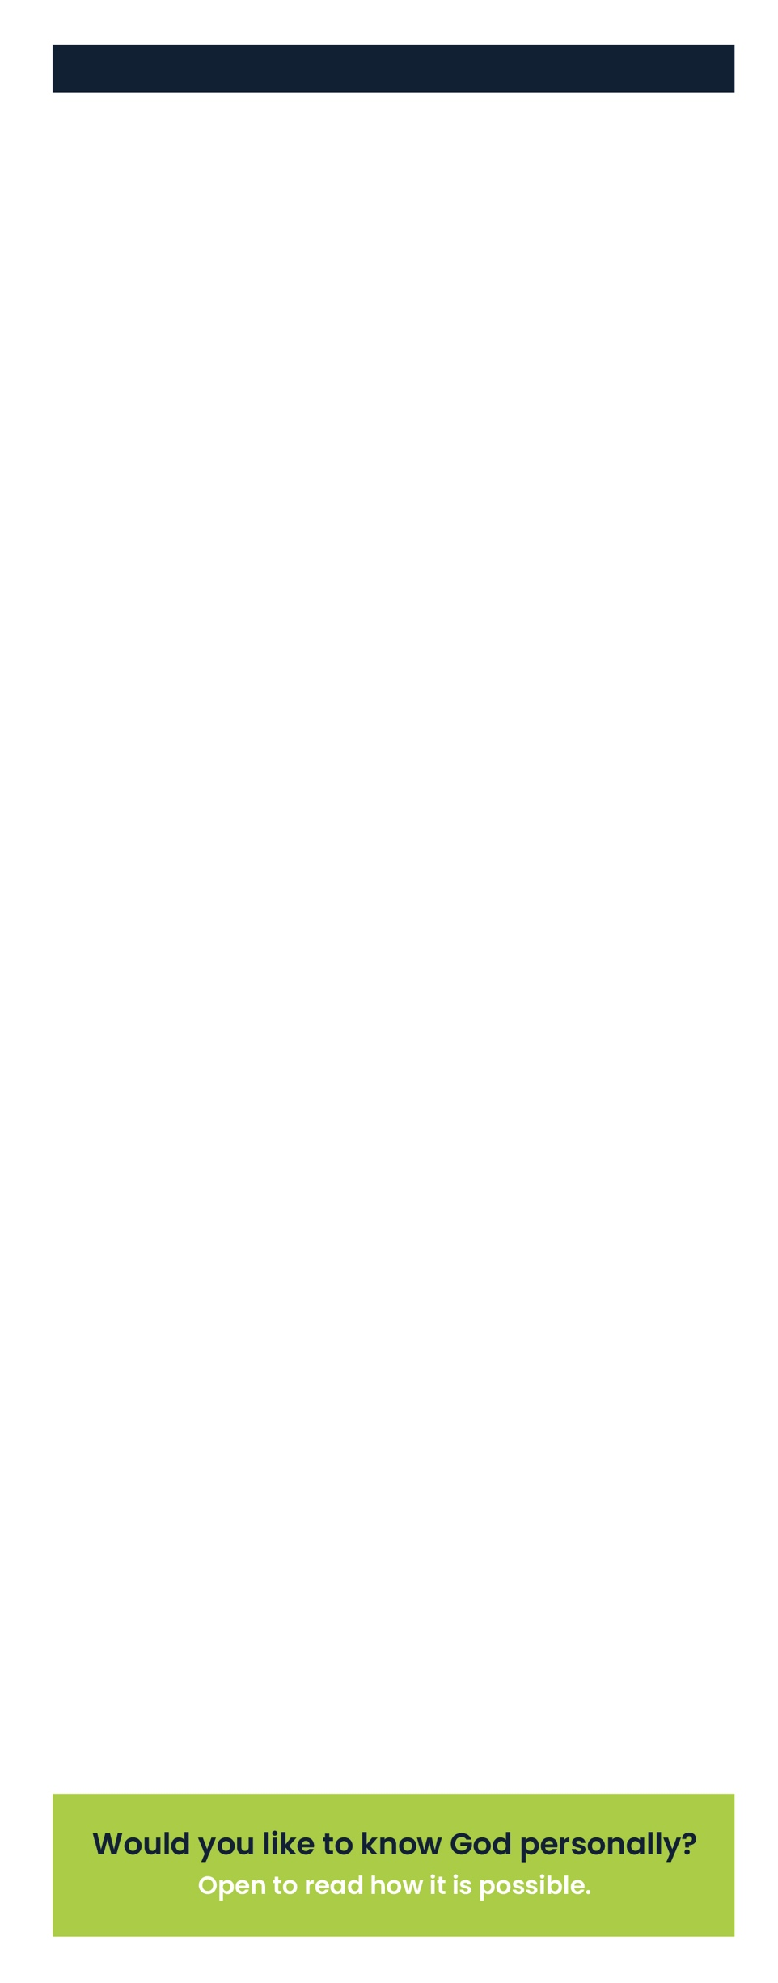
Start your testimony here.

I would be happy to pray for you or answer any
questions you may have. You can email me at:

Copyright © Grace Church 2019 all rights reserved “Life in 6 words”
Used by permission of Dare2Share, dare2share.org

